**FanFlyer - Internal Frame**

**Hardware Report 1**

**Steve Sorden**

**Corey Marcum**

**Nathaniel Schaul**

**Travis Byakeddy**

**2018-2019**

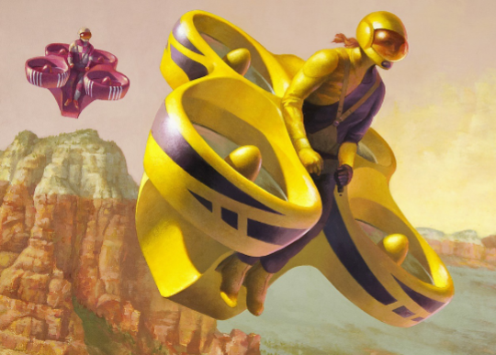

Figure 1-Novakinetics concept art [1]

**Project Sponsor: Jim Corning of Novakinetics Aerosystems**

**Faculty Advisor: Brandon Begay**

**Instructor: Dr. Trevas**

# **DISCLAIMER**

This report was prepared by students as part of a university course requirement. While considerable effort has been put into the project, it is not the work of licensed engineers and has not undergone the extensive verification that is common in the profession. The information, data, conclusions, and content of this report should not be relied on or utilized without thorough, independent testing and verification. University faculty members may have been associated with this project as advisors, sponsors, or course instructors, but as such they are not responsible for the accuracy of results or conclusions.

# **TABLE OF CONTENTS**

Contents

DISCLAIMER.. 1

TABLE OF CONTENTS. 1

1 BACKGROUND.. 3

1.1 Introduction. 1

1.2 Project Description. 1

1.3 Original System.. 1

1.3.1 Original System Structure. 1

1.3.2 Original System Operation. 1

1.3.3 Original System Performance. 1

1.3.4 Original System Deficiencies. 2

2 REQUIREMENTS. 3

2.1 Customer Requirements (CRs) 3

2.2 Engineering Requirements (ERs) 3

2.3 Testing Procedures (TPs) 3

2.4 House of Quality (HoQ) 4

3 EXISTING DESIGNS. 5

3.1 Design Research. 5

3.2 System Level 5

3.2.1 Existing Design #1: HoverBike. 5

3.2.2 Existing Design #2: EHang 184. 5

3.2.3 Existing Design #3: Quadcopter Frames 5

3.3 Functional Decomposition. 6

3.3.1 Black Box Model 6

3.3.2 Functional Model 6

3.4 Subsystem Level 6

3.4.1 Subsystem #1: Finite Element Analysis (FEA) 6

3.4.2 Subsystem #2: Design Frames from CR 6

3.4.3 Subsystem #3: Materials. 7

4 DESIGNS CONSIDERED.. 8

4.1 Design #1: Smaller Main Design 8

4.2 Design #2: Three Pole Frame 8

4.3 Design #3: Hover Pad Frame 8

4.4 Design #4: Triangular Box Frame

4.5 Design #5: Race Car Hover Pad

4.6 Design #6: Five Point Pole

5 DESIGN SELECTED – First Semester 9

5.1 Rationale for Design Selection. 9

5.2 Design Description. 9

6 CONCLUSIONS. 13

6.1 Contributors to Project Success. 13

6.2 Opportunities/areas for improvement 13

6.3 What the team has learned 13

7 REFERENCES. 25

8 APPENDICES. 26

8.1 Appendix A: Black Box model 26

8.2 Appendix B: Functional Decomposition 27

8.3 Appendix C: Decision Matrix 27

# **1 BACKGROUND**

## **1.1 Introduction**

The NAU Fan Flyer team has been given the opportunity to assist NovaKinetics Aerosystems with their design to compete in the Boeing sponsored, GoFly competition. Jim Corning, the CEO of NovaKinetics has tasked the team with designing and analyzing an interior steel frame for their manned air vehicle. The steel frame will have to support loads that add to about 900lbs. To take on this task, the team will be learning to use Finite Element Analysis (FEA) and the program Ansys, as none of the members have a background in either. Using Ansys, the team will be able to analyze their proposed designs by locating the weak points and areas of high stress on the steel frames. These calculations will then be checked by the team by performing closed-form solutions by hand.

NovaKinetics is looking for a strong and durable frame to act as the backbone for their manned air vehicle. Jim Corning is striving to win the GoFly competition as well as create a market to sell their design with the help of the Fan Flyer team’s frame. The GoFly competition is a two year long feat requiring teams from all over the world to generate a personal flying flying vehicle. After passing the first year trials, NovaKinetics is looking to bring home the million dollar prize in the second year with the help of the NAU Fan Flyer team.

## **1.2 Project Description**

Following is the original project description provided by NovaKinetics Aerosystems; “The FanFlyer will have a ladder structure of welded 4130 steel tubing that connects the engine,

landing gear, reversing gearbox, pilot restraint harness mounting points, and ballistic parachute

harness anchor point. This steel tube structure will also interface with the carbon fiber shell

structure that forms the ducted fan housings. Each ducted fan will have a structural outer shell

that connects with the steel tube frame, and an inner duct that is removable, along with the fan

hub and supports, for maintenance and for easy updating of ducted fan components.” [1]. In addition to this, the team has to learn the program Ansys to design this frame.

## 

## 

## **1.3 Original System**

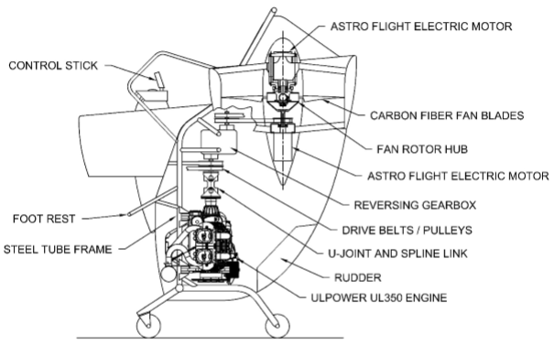

Figure 2 -Original System Layout [1].

The original system structure for the design shown in Figure 2 has already been designed by NovaKinetics. The system includes everything for the manned air vehicle besides the steel frame required from the FanFlyer team. Because there was no original system for the frame at the beginning of this project, it is considered a new design. The FanFlyer team can be creative and generate a frame not based on previous designs. Thus, there is no data showing how the original system operated, performed, and failed.

### **1.3.1 Original System Structure**

The original system, as can be seen above in figure 2 houses the four rotors, a combustion engine, generic pilot seat with controls, and generic landing wheels. Figure 3 below shows an isometric view of the the rotor, crank shaft, and combustion engineering only. This is the foundation of the original system above in figure 2.

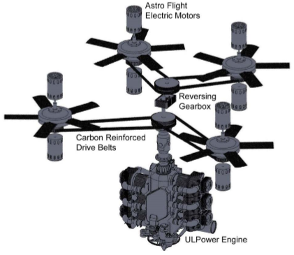

Figure 3 - Powertrain layout [1]

### **1.3.2 Original System Operation**

Because the original system is still in the process of manufacturing, there is no data regarding the operation as it has not been tested.

### **1.3.3 Original System Performance**

This project and Flyer is the first of its kind with Novakinetics and as such there is no original performance because as stated it has not been constructed yet.

### **1.3.4 Original System Deficiencies**

This is not applicable to team FanFlyer at the moment of this report because this is a new project from the ground up.

# **2 REQUIREMENTS**

In section 2 the team evaluates the requirements put forth by the client and engineering industry. The FanFlyer team will use the requirements discussed to prioritize the aspects of the project into an order of operations in which to complete the project to the best manner possible. This is done in order to exceed the expectations of the client by meeting and or exceeding industry standards associated with the project.

## **2.1 Customer Requirements (CRs)**

2.1.1 Lightweight: This requirement was specified by the client as the highest level of importance because in order to compete in the GoFly competition the FanFlyer must first pass the weight limit test. This is why the lightweight requirement was weighted the highest.

2.1.2 Increase factor of safety: This Implies that in the design process the factor of safety should be increased through the inclusion of the structure design. By adding design aspects such as pilot restraints and roll cage design the team aims to achieve this goal. Safety is always paramount and is weighted the second highest of the requirements.

2.1.3 Balance/ Stability: Balance and stability are largely important throughout the aerospace industry. In order to achieve flight the design must be perfectly balanced and stabilized. This is the reason behind a third highest weighting.

2.1.4 Minimize Joint failure: The FanFlyer will be put under various strains throughout takeoff, flight, and landing. Stress and strains tend to be localized at joints. As a result it is important that the design be evaluated so that failure doesn’t occur within the area of joints. The weighted value is tied for fourth importance as a result of this.

2.1.5 Withstand Impact: Reasonably the FanFlyer design includes numerous safety factors in order to reduces chances of hard or unexpected collisions; however, It is vital that in the unlikely event of such occurrence the frame should be able to withstand the impact of the collision in order to protect the persons and cargo aboard. This requirement has received a weighted score equal to the fourth important requirement.

2.1.6 Strong: Strength is integral in this design project because as it is the main point of contact for the entire structure it must be able to withhold the various stresses it will be placed under. As a result this requirement was weighted tied for fifth in importance.

2.1.7 Durable: In the future our client intends to license this product for military applications. For this to be a realistic application of the product it must be durable in order to endure the various types of terrain and conditions that the military operates under. For this reason it is rated as the fifth most important requirement.

2.1.8 Ease of assembly: In order to meet the client's future expectation of producing large scale and commercial applications of the FanFlyer the frame must be designed with manufacturing in mind. Though is isn't a life or death requirement it is still a requirement necessary of consideration and as such is weighted sixth most important.

2.1.9 Aesthetically Pleasing: Our client is designing the Fanflyer with commercialabilty in mind. As a result it is important that customers appreciate the elegance of the design. Aesthetics play an important role in the consumer market and as a result should be considered for evaluation. The requirement establishes itself as the seventh most important requirement.

2.1.10 Ability to incorporate landing gear: This was not a specific requirement that the client was looking for. He proposed it as more of a challenge to the design team. For that reason it has been weighted as least important.

## **2.2 Engineering Requirements (ERs)**

2.2.1 Lowest cost of materials: It is important to the client that a budget be considered for a realistic design proposal. Therefore throughout the project it is important to consider the best performing materials that are priced within reason.

2.2.2 Total empty weight < 625 lbs: The competition requires the total weight including pilot and fuel to be under 900 lbs. Therefore, the design must be engineered with empty weight restraint so that the design will fall within the competition requirements.

2.2.3 Total volume < 275 ft^3: This requirement breaks down even farther into individual requirements for each height, length, and width. For simplicity, however, the restraint was put on the entire volume of the design.

2.2.4 Precision of structural analysis: In industry, in order for regulations to be met the design calculation must be as accurate as possible. As a result the design analysis must be precise to within a target of 1% of the necessary structural demand.

2.2.5 Analysis Delivered at least 1 month before construction date of March 19th: It is important to have to design and analysis completed and returned to the client before the date in order for project to stay on schedule for the overall competition.

2.2.6 Factor of Safety within aircraft tolerances: The design must meet all industry standards for private flight aircrafts. In order to be considered safe and reliable it is important that the design meet or exceed the industry standard factor of safety.

2.2.7 Structure within standard for FAR part 23 and part 27: The FAA has produced standards for structural loads of small private aircrafts. Since this project technically falls under this definition, it is crucial for the specifications of the structural loads to meet FAR part 23 and 27 and will be used as a guideline throughout the design.

2.2.8 Deflection and Stress within tolerance: Over time it is inevitable that components of the project will wear down with use. It is important that we evaluate the life cycles of the structure to ensure the deflection will not exceed working standard. This may be inevitable, so it is important to understand when these factors become too high to remove the product from operation for safety.

2.2.9 Pilot Drag coefficient < .5: It is important for optimal efficiency and flight control that the drag forces on the pilot not exceed this limit. This is a crucial design element to be considered in the project in order to produce an actual working model.

## **2.3 Testing Procedures (TPs)**

## **2.4 House of Quality (HoQ)**

# **3 EXISTING DESIGNS**

## **3.1 Design Research**

## **3.2 System Level**

### **3.2.1 Existing Design #1: Hoverbike**

### **3.2.3 Existing Design #3: Quadcopter Frames**

## **3.3 Functional Decomposition**

### **3.3.1 Black Box Model**

### **3.3.2 Functional Model**

## **3.4 Subsystem Level**

### **3.4.1 Subsystem #1: Finite Element Analysis (FEA)**

#### **3.4.1.1 Existing Design #1: ANSYS**

#### **3.4.1.2 Existing Design #2: Matlab**

#### **3.4.1.3 Existing Design #3: SolidWorks**

### **3.4.2 Subsystem #2: Design Frames from Customer requirements**

#### **3.4.2.1 Existing Design #1: Concept # 3**

#### **3.4.2.2 Existing Design #2: Concept #4**

#### **3.4.2.3 Existing Design #3: Concept #6**

### **3.4.3 Subsystem #3: Materials**

#### **3.4.3.1 Existing Design #1: 4130 Steel**

#### **3.4.3.2 Existing Design #2: Aluminum**

#### **3.4.3.3 Existing Design #3: Cold rolled steel**

# **4 DESIGNS CONSIDERED**

## **4.1 Design #1: Smaller Main Design**

## **4.2 Design #2: Three Poll Frame**

## **4.3 Design #3: Hover Pad Frame**

## **4.4 Design #4: Triangular Box Frame**

## **4.5 Design #5: Race Car Hover Pad**

## **4.6 Design #6: Five Point Pole**

# **5 DESIGN SELECTED – First Semester**

## **5.1 Rationale for Design Selection**

## 

## **5.2 Design Description**

**6 CONCLUSIONS**

## **6.1 Contributions to the Project’s Success**

## **6.2 Opportunities/ areas for improvement**

**6.3 What The Team Has Learned**

# **7 REFERENCES**

[1] FanFlyer Potential Technical & Design Discussion. Novakinetics. 2018. Journal copyright 2018.

[2] "This Hoverbike Is Basically A Giant Quadcopter Drone". Motherboard. N.p., 2017. Web. 23 Apr. 2017.

[3] "This Insane Car-Sized Drone Carries People Like A Helicopter". Time.com. N.p., 2017. Web. 23 Apr. 2017.

[4] **THE BEST QUADCOPTER FRAMES**

FPV Know-It-All - Joshua Bardwell. (2018). *THE BEST QUADCOPTER FRAMES*. [online] Available at: https://www.fpvknowitall.com/ultimate-fpv-shopping-list-frame/ [Accessed 26 Oct. 2018].

### **[5]** Ansys.com. (2018). *Engineering Simulation & 3D Design Software | ANSYS*. [online] Available at: https://www.ansys.com/ [Accessed 27 Oct. 2018].

# 

# 

# **8 APPENDICES**